XR Teleoperation Subsystem Technical Documentation

Overview
This subsystem enables real-time teleoperation of a UR3e robot arm using a Meta Quest 2 VR headset. The operator's hand and controller pose is streamed from Unity into ROS 2, filtered, and converted into velocity commands that drive the robot via MoveIt Servo.

Key features:
- 6-DoF position and orientation control via VR controller
- Startup snap: hand position and orientation align to the robot end-effector on enable
- Authority filter: deadband, workspace clamping, step limiting
- Drawing modes: standard, precision, and detachment mode
- PC keyboard fallback for testing without a headset

Dependencies

Hardware
- UR3e robot arm
- Meta Quest 2 headset with developer mode enabled, and controller
- Host PC with ethernet, WiFi, and USB-C capability

Software
- Ubuntu 22.04
- ROS 2 Humble
- moveit2: MoveIt 2 with MoveIt Servo (moveit/moveit2)
- Universal_Robots_ROS2_Driver: includes ur_robot_driver and ur_moveit_config (UniversalRobots/Universal_Robots_ROS2_Driver)
- ROS-TCP-Endpoint v0.7.0: ROS side of Unity bridge (Unity-Technologies/ROS-TCP-Endpoint)
- Unity 2022.3.62f3 with Android Build Support module installed
- OpenXR Plugin (com.unity.xr.openxr)
- XR Interaction Toolkit (com.unity.xr.interaction.toolkit)
- Meta XR SDK / Oculus XR Plugin (com.unity.xr.oculus): for Quest 2 controller input
- ROS-TCP-Connector v0.7.0-preview: Unity package, must match endpoint version (Unity-Technologies/ROS-TCP-Connector)
- ADB (Android Debug Bridge): for APK deployment to Quest 2

Network Configuration
Before configuring, find your laptop's IP by running the following command in a terminal:

hostname -I

Note that there may be more than one IP listed. The Quest 2 and the host laptop must be on the same WiFi network. Make sure to note which IP corresponds to the WiFi interface.

In the URCaps External Control settings on the teach pendant, set the host IP to your laptop's IP. The robot's IP address can be found on the teach pendant under Settings, then System, then Network.

The Unity APK has the host laptop's IP hardcoded at build time. Set the ROSConnection IP in the Unity Inspector to your laptop's WiFi IP before building the APK. If the network changes, the APK must be rebuilt with the updated IP.

Installation

ROS Workspace
Clone the repository and build the workspace:

cd ~/XR_Teleoperation
rosdep install --from-paths src --ignore-src -r -y
colcon build --symlink-install
source install/setup.bash

Unity APK Deployment
Connect the Quest 2 via USB and verify the device is detected:

adb devices

Install the APK to the connected headset:

adb install -r /path/to/build.apk

Running the System

Step 1: Full Clean Reset
Always run this before launching to eliminate stale node instances. Multiple instances of the same node publishing simultaneously will cause the robot to move on its own.

pkill -f pose_error_to_twist; pkill -f unity_authority_filter_servo; pkill -f ee_tf_to_pose;
pkill -f teleop_mode_manager; pkill -f servo_auto_start; pkill -f default_server_endpoint;
pkill -f ur_ros2_control_node; pkill -f servo_node; pkill -f robot_state_publisher;
pkill -f controller_manager; pkill -f move_group
ros2 daemon stop && sleep 1 && ros2 daemon start

Step 2: Launch ROS Stack
For simulation only, start URSim in a separate terminal first:

source /opt/ros/humble/setup.bash
docker rm -f ursim 2>/dev/null || true
ros2 run ur_client_library start_ursim.sh -m ur3e

In URSim or on the teach pendant, set the joint angles to: Base 0, Shoulder -90, Elbow 90, Wrist1 180, Wrist2 -90, Wrist3 270 degrees, then hit Play.

Then launch the full ROS stack:

cd ~/XR_Teleoperation && source install/setup.bash
ros2 launch ur_unity_bringup ur3e_unity_bridge_servo.launch.py \
use_fake_hardware:=false \
robot_ip:=<robot_ip> \
ros_ip:=0.0.0.0

Step 3: Start Robot Program
On the teach pendant, run the External Control program. The servo_auto_start node will confirm when the velocity controller is active in the launch terminal output.

Step 4: Start APK
Launch the app on the headset:

adb shell monkey -p com.StephenCSui.XRTeleop 1

To record the headset screen:

adb shell screenrecord /sdcard/capture.mp4
# Stop with Ctrl+C, then pull to desktop:
adb pull /sdcard/capture.mp4 ~/Desktop/capture.mp4

Step 5: Enable Teleoperation
In the headset, press the teleop enable button. The hand will snap to the robot end-effector position. Move the controller to drive the robot.

Subsystem Architecture

Control Pipeline
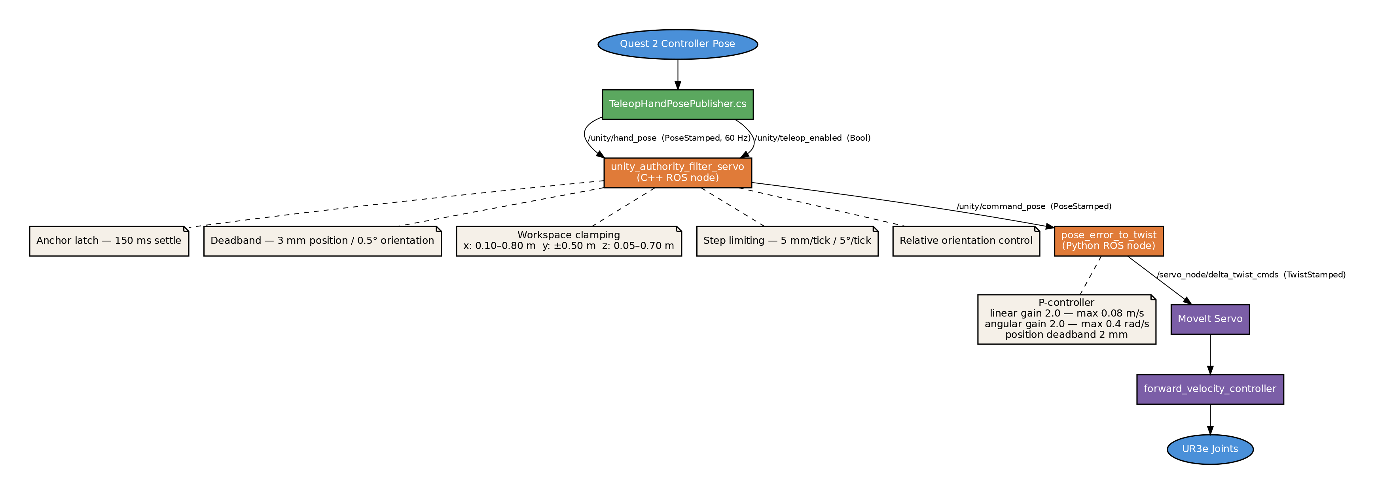

Feedback Loop
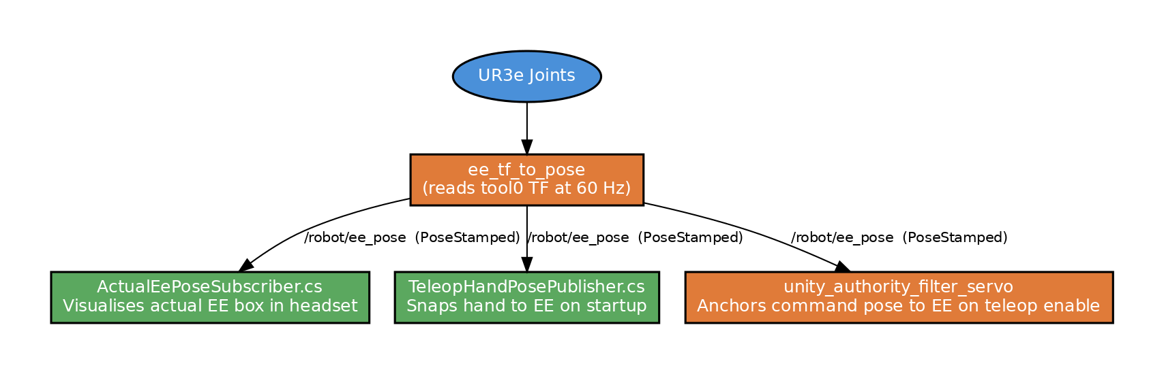

ROS Nodes
- ee_tf_to_pose (ur_unity_bringup): Reads tool0 TF, publishes /robot/ee_pose at 60 Hz
- unity_authority_filter_servo (unity_authority_filter_servo_cpp): Main filter: gates, clamps, and scales hand commands
- pose_error_to_twist (ur_unity_bringup): P-controller: converts command pose error to twist velocity
- servo_auto_start (ur_unity_bringup): Waits for robot program, activates velocity controller
- teleop_mode_manager (ur_unity_bringup): Publishes active mode (NORMAL or PRECISION) and proximity
- ros_tcp_endpoint (ros_tcp_endpoint): TCP bridge between Unity and ROS

ROS Topics
- /unity/hand_pose (PoseStamped): Unity to unity_authority_filter_servo
- /unity/teleop_enabled (Bool): Unity to unity_authority_filter_servo
- /unity/command_pose (PoseStamped): unity_authority_filter_servo to pose_error_to_twist and Unity visualiser
- /robot/ee_pose (PoseStamped): ee_tf_to_pose to Unity and unity_authority_filter_servo
- /servo_node/delta_twist_cmds (TwistStamped): pose_error_to_twist to MoveIt Servo
- /teleop_mode/active_mode (String): teleop_mode_manager to unity_authority_filter_servo

Unity Scripts
- TeleopHandPosePublisher.cs: Reads controller pose, publishes hand pose, snaps hand to end-effector on startup
- CommandSubscriber.cs: Subscribes to /unity/command_pose, drives command box visual
- ActualEePoseSubscriber.cs: Subscribes to /robot/ee_pose, drives actual end-effector visual
- HandTargetDemoPublisher.cs: PC keyboard fallback: WASD and arrow keys to drive hand pose
- CanvasPainter.cs: Canvas drawing feature for pen-down interaction

Coordinate Conventions
Unity and ROS use different coordinate systems. All conversions are applied at the ROS-TCP boundary:

- Unity X maps to ROS -Y
- Unity Y maps to ROS +Z
- Unity Z maps to ROS +X

Position conversion: RosToUnityPosition(ros) returns (-ros.y, ros.z, ros.x)
Rotation conversion (Unity to ROS quaternion): (-rosQ.y, rosQ.z, rosQ.x, -rosQ.w)

Key Configurable Parameters
All tunable parameters are set in src/ur_unity_bringup/launch/ur3e_unity_bridge_servo.launch.py. No rebuild is required: parameters are read at launch time.

Authority Filter
- hand_deadband_m (0.003): Ignore hand motion below this distance in metres
- max_cmd_step_m (0.005): Maximum command position step per tick in metres
- max_cmd_angle_step_deg (5.0): Maximum command orientation step per tick in degrees
- position_scale (1.0): Uniform position scaling
- x_min / x_max (0.10 / 0.80): Workspace X bounds in base_link in metres
- anchor_settle_ms (150): Settle time after teleop enable before anchor latches

P-Controller
- linear_gain (2.0): Position error to linear speed gain
- max_linear_speed (0.08): Linear speed cap in metres per second
- angular_gain (2.0): Orientation error to angular speed gain
- max_angular_speed (0.4): Angular speed cap in radians per second
- position_deadband_m (0.002): Do not move if position error is below this in metres

Testing Without Headset
HandTargetDemoPublisher.cs provides keyboard-driven control for testing the full pipeline without a VR headset. To use it:

- Disable the TeleopHandPosePublisher GameObject in the scene
- Enable the HandTargetDemoPublisher GameObject
- Hit Play in the Unity editor
- WASD moves the hand forward, back, left, and right
- Q and E move up and down
- Arrow keys control yaw and pitch, Z and X control roll

The script snaps to the end-effector on start and publishes to the same topics as the VR path.

Troubleshooting

Robot moves by itself on launch
Multiple stale instances of pose_error_to_twist are publishing simultaneously. Run the full clean reset from Step 1. Verify by checking the publisher count:

ros2 topic info /servo_node/delta_twist_cmds --verbose | grep 'Publisher count'
The count should be 1.

Command box jumps away from hand on teleop enable
The end-effector starting position is outside the workspace bounds. Check the ee_r value in the ANCHOR log printed at teleop enable. If ee_r.x is below x_min, lower x_min in the launch file. Also verify the robot is in the correct starting joint pose.

ADB device shows unauthorized
The USB debugging prompt did not appear in the headset. Developer mode must be enabled and accepted from the owner Meta account. Switch to the owner profile in the headset and replug the USB cable.

APK connects but no robot motion
Verify that the ROS-TCP-Connector IP in the APK matches the host laptop's WiFi IP, and that the Quest 2 and host machine are on the same WiFi network.

servo_auto_start never confirms
The robot program on the teach pendant is not running, or the External Control URCap is not configured correctly. Confirm the External Control host IP matches your laptop's ethernet IP. Run the program on the teach pendant manually.

Known Limitations
- Orientation control is relative to the anchor at teleop enable. Large rotations near gimbal-lock poses (pitch near 90 degrees) cause orientation display instability, which is physically correct but visually confusing.
- There is no collision avoidance. Workspace bounds are the only safety constraint. Ensure the robot has clearance before enabling teleoperation.
- The ROS-TCP-Connector version is pinned to v0.7.0-preview and must match the ros_tcp_endpoint version exactly. Do not update either independently.
- The APK ROS-TCP IP is hardcoded at build time. Changing networks requires a rebuild.

